Service Manual For Surface Grinders

Machine Parts Nomenclature

Surface Grinder

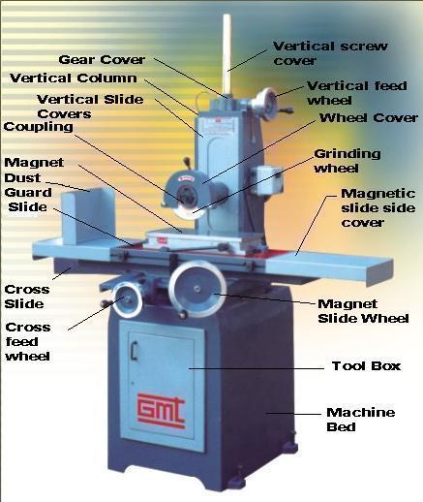

Service Manual For Surface Grinders

Installation & Service Instructions

- Place the machine on clean & horizontal leveled floor. Adjust the leveling screws to level the magnetic table using spirit level indicator.

- Remove the magnetic slide side cover & fill the oil (Shell 10 or equivalent) upto the level of 3 to 4 mm on flat slide ( Approx quantity of oil is 4 to 5 litres ).

- Make machine’s electrical connections to the power supply & check the wheel rotation as indicated on wheel cover.

- Before starting the machine lubricate the slides & screws by pumping lubrication pump.

- Dress the grinding wheel, remove the wheel along with coupling from machine & balance the wheel on balancing stand & again mount the wheel on machine.

- Now your machine is ready for operation.

Service Manual For Surface Grinders

Trouble Shooting

- In case any taper is observed in work piece, check the magnet surface using dial indicator (within 0.01mm/ full length of magnet). If any surface damage or taper is observed, grind the table slowly & with light cuts (max 0.05 mm).

- In case vibration is observed, dress the wheel & balance it on balancing stand. Also check the spring tension of spindle after removing the wheel cover.

- In case of any uneven movement in vertical slide, remove the covers of vertical slides & clean with diesel or equivalent oil & lubricate properly.

For any other defects mentioned above please contact

M/s Guru Machine Tools
3E/3, B.P. , N.I.T. Faridabad
Haryana (India)
Ph : 0129-2480412, 0129-2481184
Fax : 0129-2480666

Service Manual For Surface Grinders

Preventive Maintenance Schedule

Particulars | Daily | Monthly | Annually
Cleaning & Oiling
Check oil level in magnet slide
Oil level in lubrication pump (shell 20/40)
Cleaning of vertical slides by removing front & rear covers

Check the motor & spindle for any undue noise.
Greasing of Spindle
(if required call service engineer)
Grind the magnet surface
(very light cuts (max 0.05 mm)

